**CONCAT-MIRROR (-m1) INCREASE**

**First to create a instance**

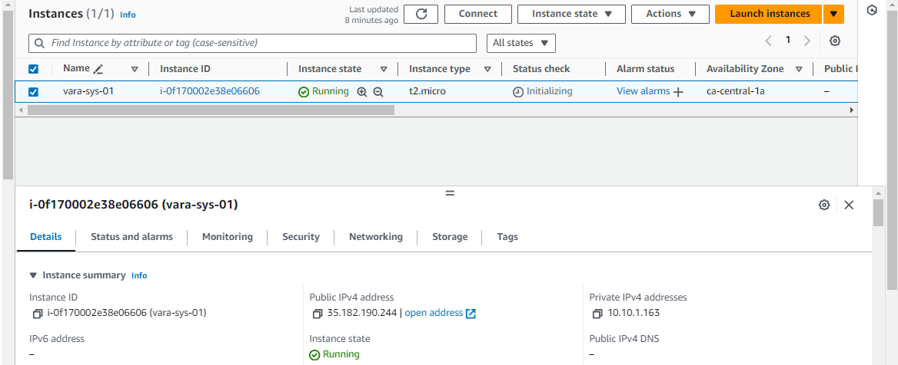

* two volumes created

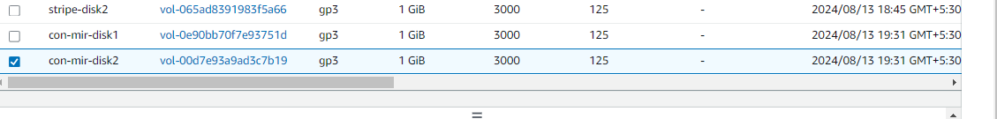

* **Now we can attach the volume (con-mir-disk1) to the above instance*.***
* **Then follow bellow steps**

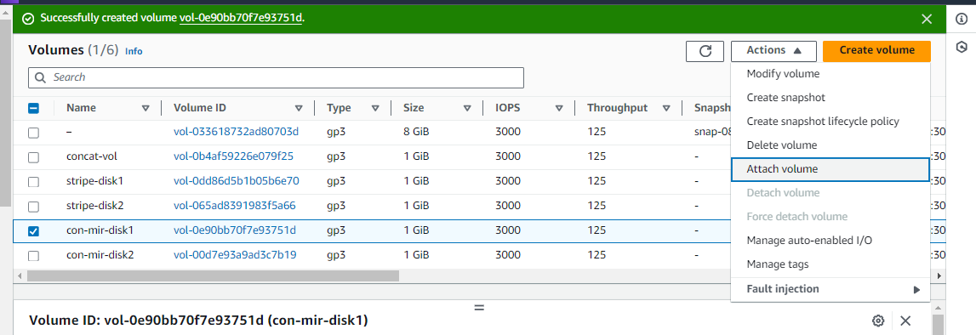

***select the instance id and select the device name (/dev/sde) then click on attach volume option.***

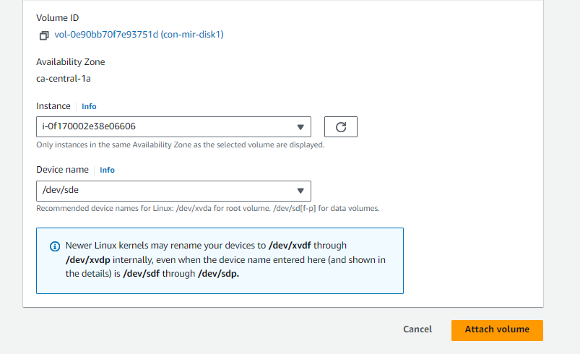

Same above attach volume like

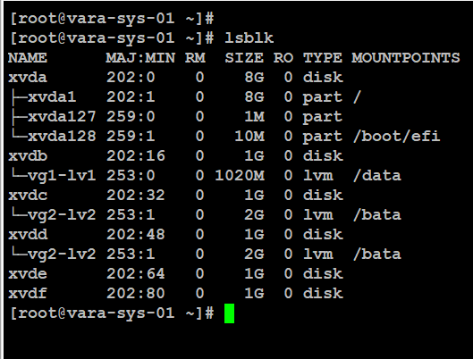checking with lsblk volumes attached or not .

* **to create a physical volume and check pv created or not.**
* **Then to create a volume group and check vg created or not.**

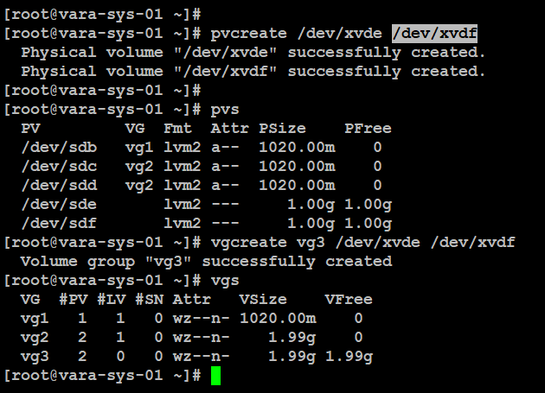

* Then Lvcreate using bellow command

Checking with commands #lvs –segment or #lvdisplay and #lvscan

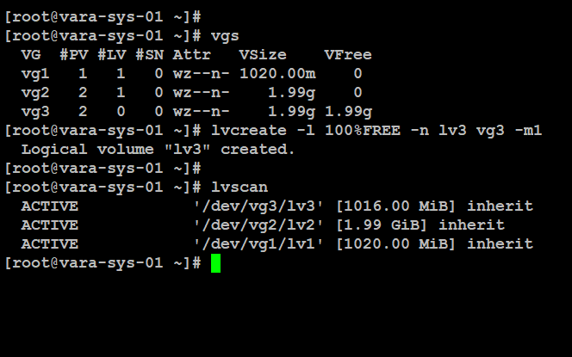

* To check how many volumes (disks) participated in lv3 by using this command.

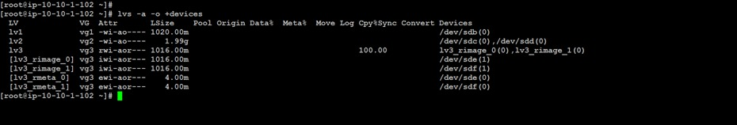

Then to make a file system and create a mount point then persistence across reboot put in fstab entry.

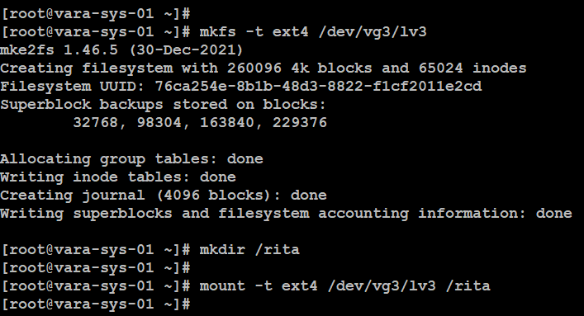

* check the mounted file system information df -h /rita and keep some data

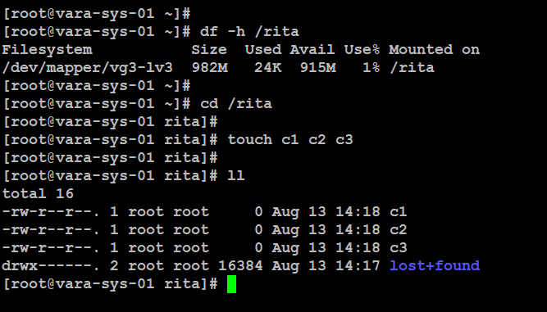

TO INCREASE CONCAT MIRROR (-m1)

First select the volume and select actions goto modify volume

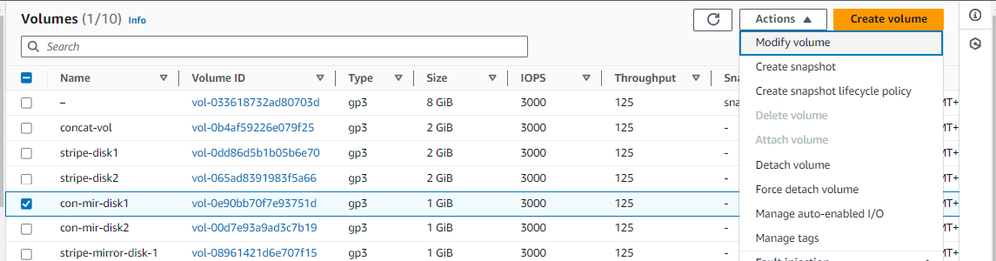

* Next change only volume size 1GB to 2GB.

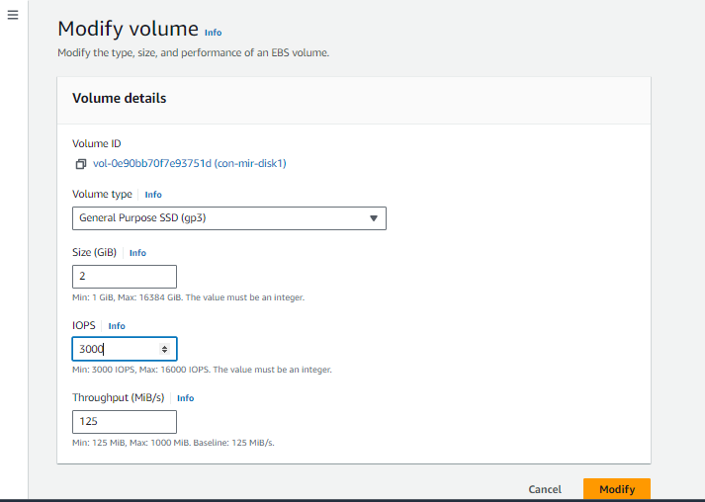

Then click on modify option

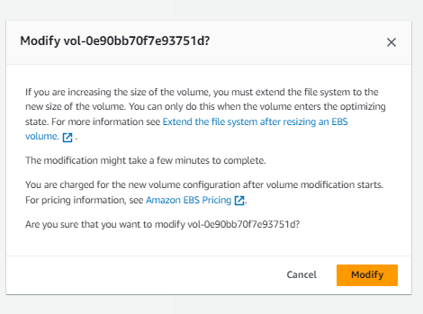

Next select the second volume and goto actions and select modify .

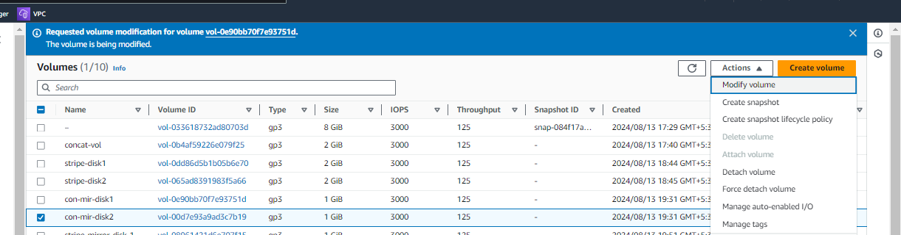

then changed volume size 1GB to 2GB.Then clickon modify

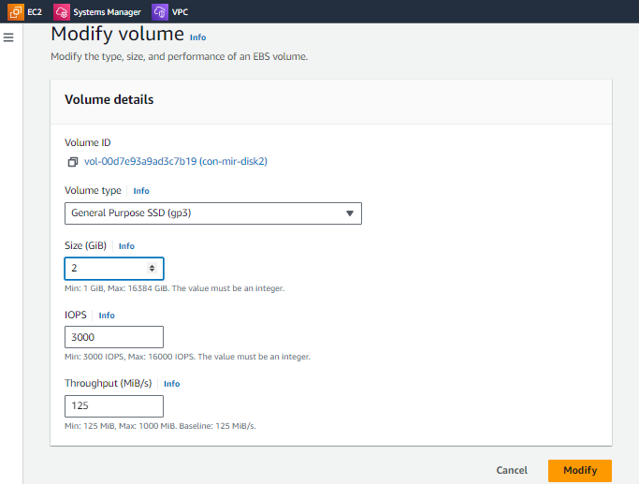

After modify the volume aws dash board level volume can be increased.

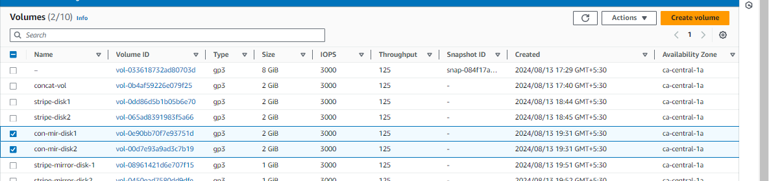

After modify volume check with lsblk also changed but os level cannot appear.

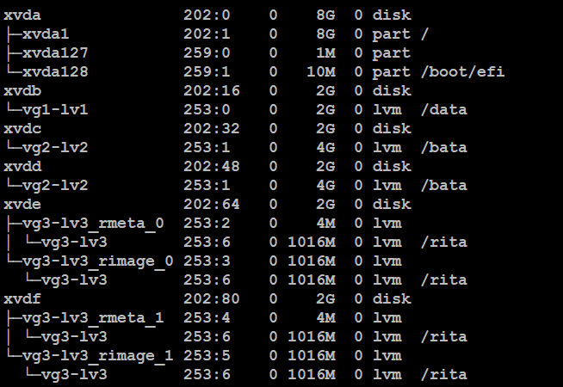

* Then to resize a physical volume and check pv created or not.
* After resize pv then automatically updated to volume group also.

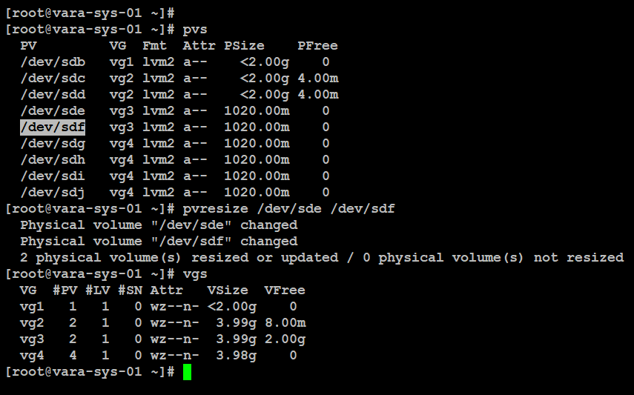

Then to extend the logical volume .

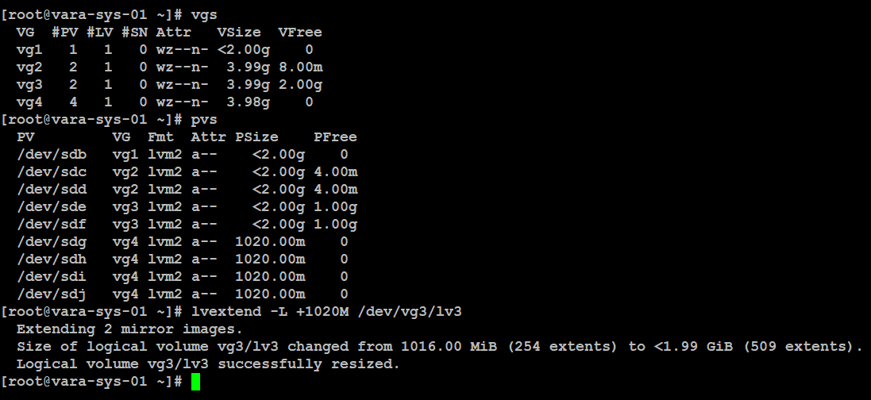

* extending logical volume, . But df –h cannot increase.
* we need to resize the logical volume then it will update to os level also.

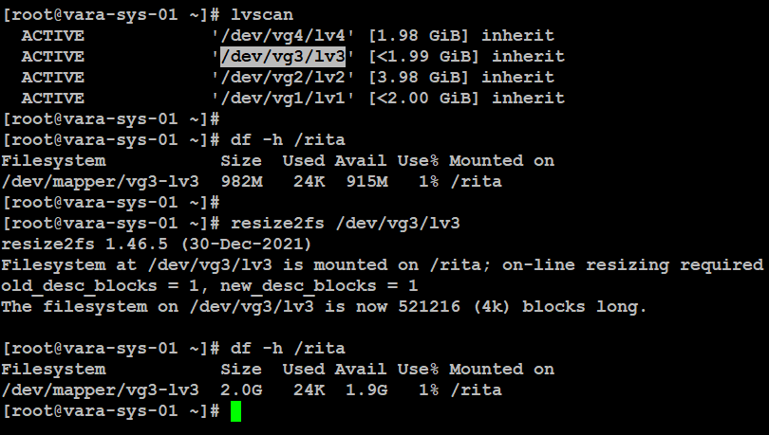

* after increase the volume previous data can be available.

